10 EPOCHS:

Epoch 1, total time 489.58
train_loss average 0.5423021880938457
-----------------------------------
Epoch 2, total time 496.39
train_loss average 0.45796594326312723
-----------------------------------
Epoch 3, total time 496.68
train_loss average 0.3603976399394182
-----------------------------------
Epoch 4, total time 499.41
train_loss average 0.30775080412626266
-----------------------------------
Epoch 5, total time 497.69
train_loss average 0.29558285023157416
-----------------------------------
Epoch 6, total time 499.01
train_loss average 0.29039792276345766
-----------------------------------
Epoch 7, total time 501.88
train_loss average 0.28116441011428833
-----------------------------------
Epoch 8, total time 500.29
train_loss average 0.2749933844346267
-----------------------------------
Epoch 9, total time 507.50
train_loss average 0.27625745688493436
-----------------------------------
Epoch 10, total time 498.86
train_loss average 0.26553691322986894

RESULTS:

Average test IoU: 0.7202
Average Dice: 0.8091

TRAINING LOSS VISUAL:
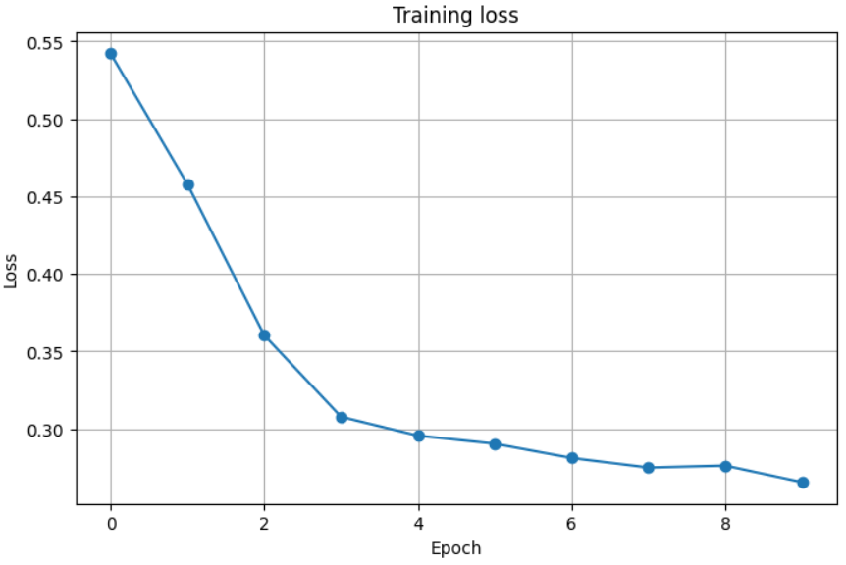

3 SETS OF EXAMPLE IMAGES:
